Assignment 1.2

1.pwd

It prints the full pathname of the current working [directory](https://www.computerhope.com/jargon/d/director.htm).

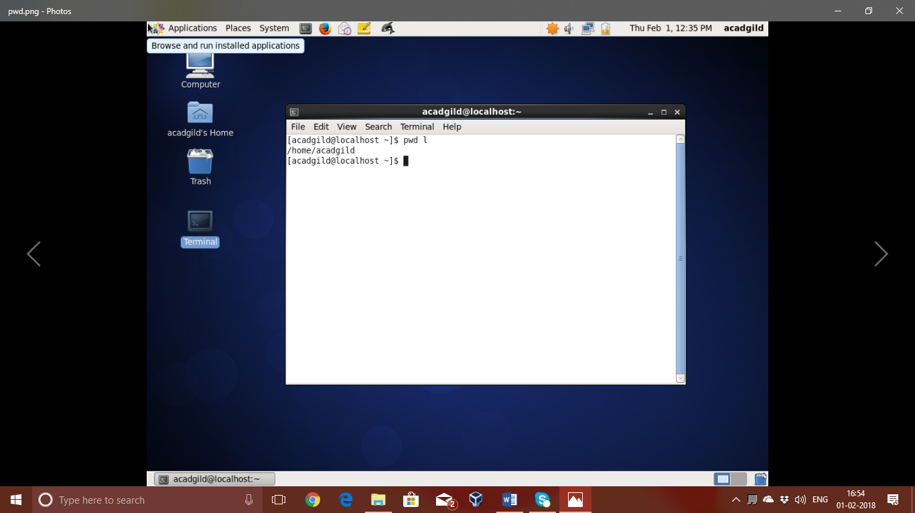

2.vi

It is an interactive text editor. the screen of your [terminal](https://www.computerhope.com/jargon/t/terminal.htm) acts as a window into the file you are editing. Changes you make to the file are reflected in what you see.

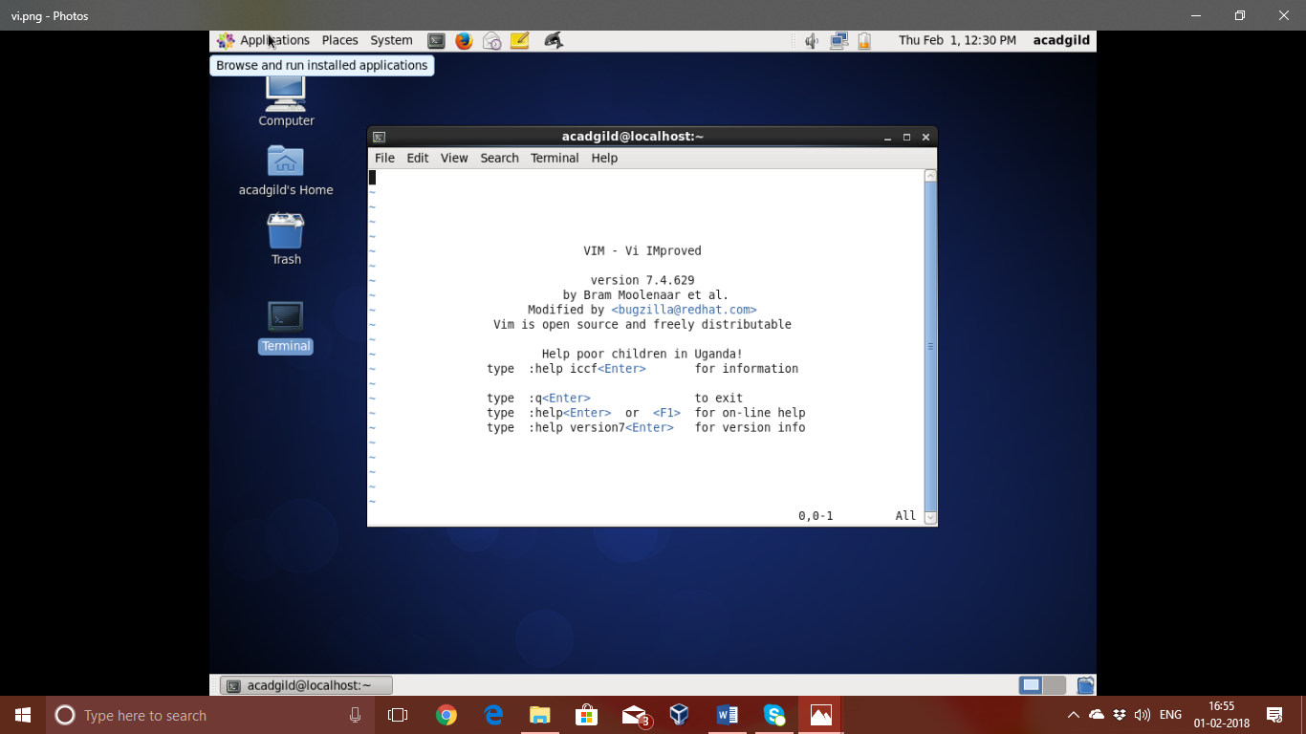

3.touch

It is the easiest way to create new, empty files. It is also used to change the timestamps on existing files and directories.

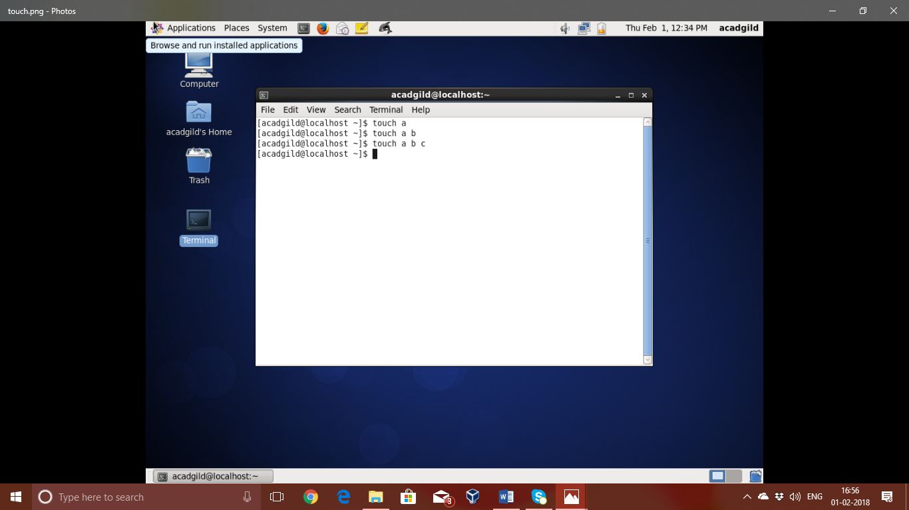

4.mkdir

It is used to create new directories. A directory, referred to as a folder in some operating systems, appears to the user as a container for other directories and files.

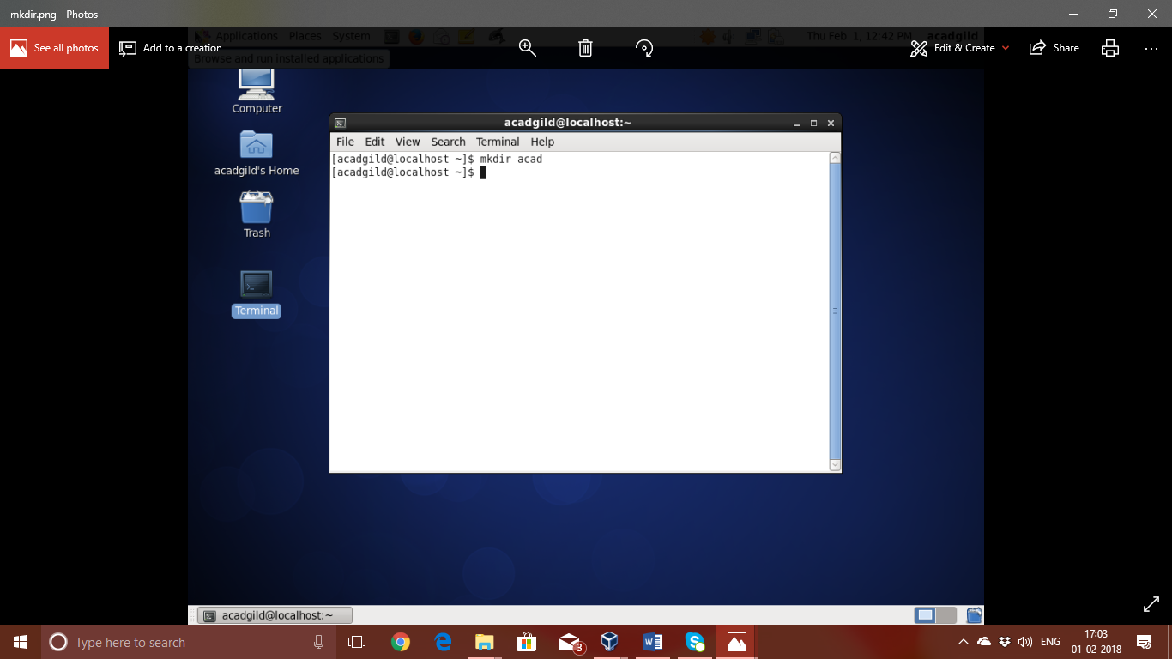

5.rm

It is used to delete files and directories on linux. Error messages are returned if a file does not exist or if the user does not have the appropriate permission to delete it.

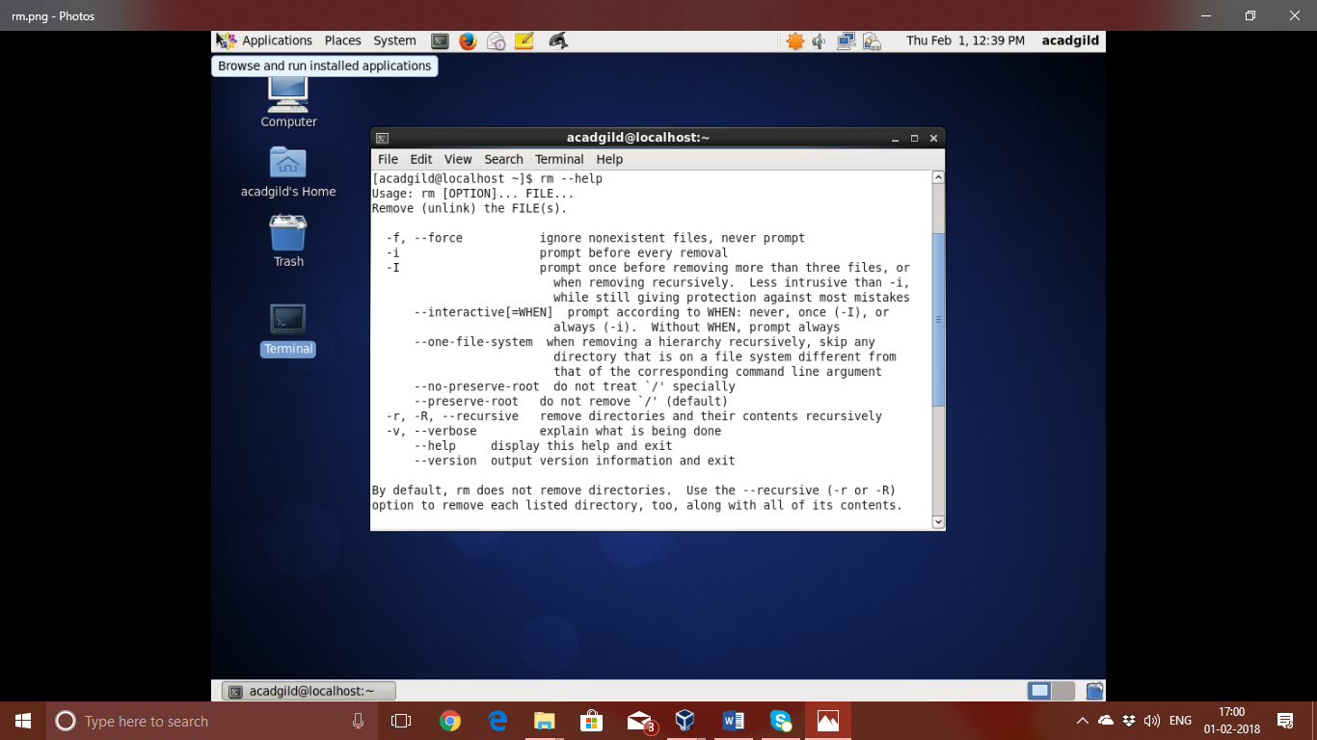

6.ls

**ls** is used to lists directory contents of files and directories.

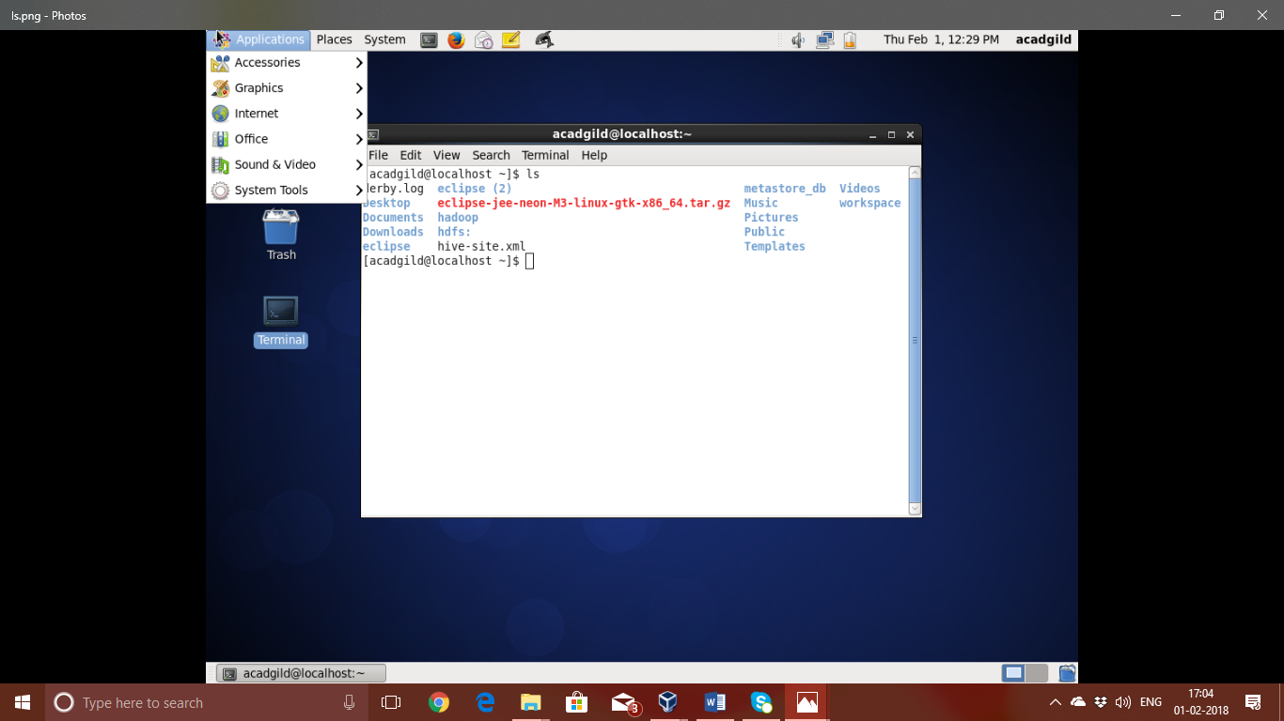

7.echo

**echo** command is used to print the text or string as a output

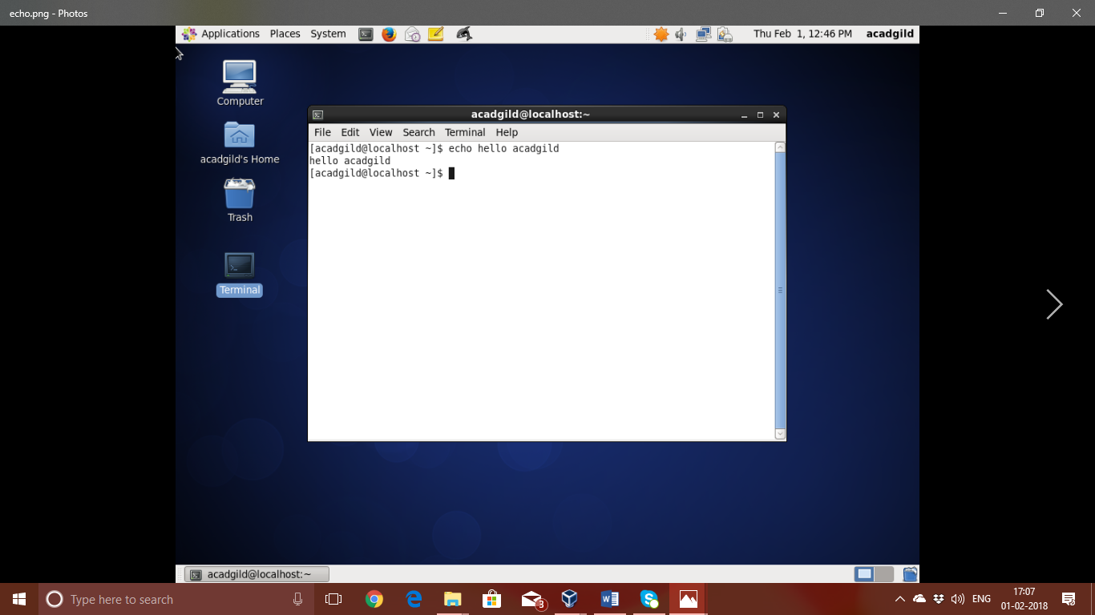

8.cat

The cat command is one of the most frequently used command in Linux/Unix like operating systems. cat command allows us to create single or multiple files, view contain of file, concatenate files and redirect output in terminal or files.

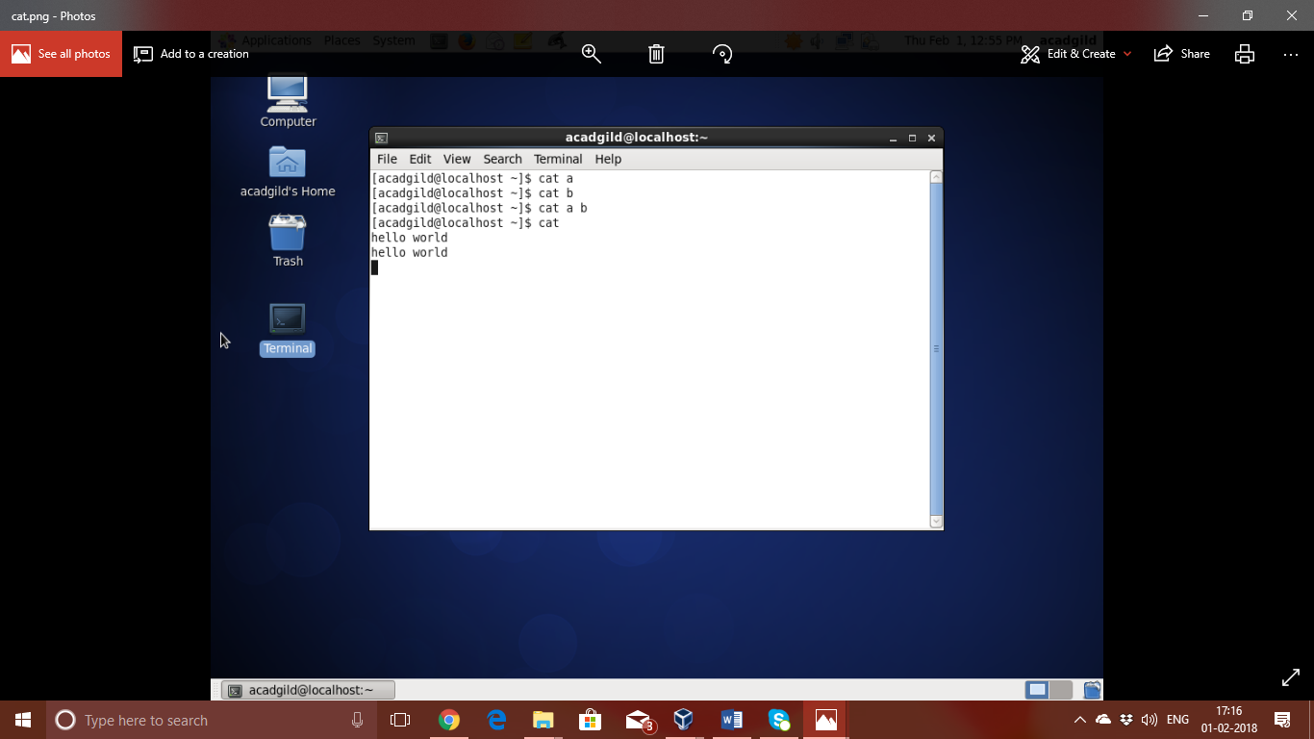

9.who

It is used to prints information about all users who are currently logged in.

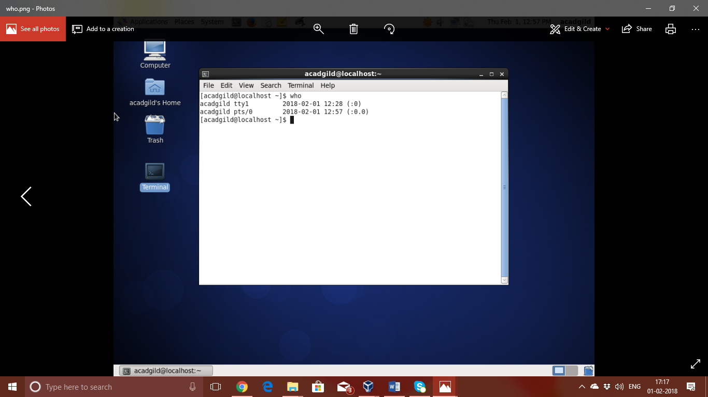

10.cd

it is used to change the current directory.

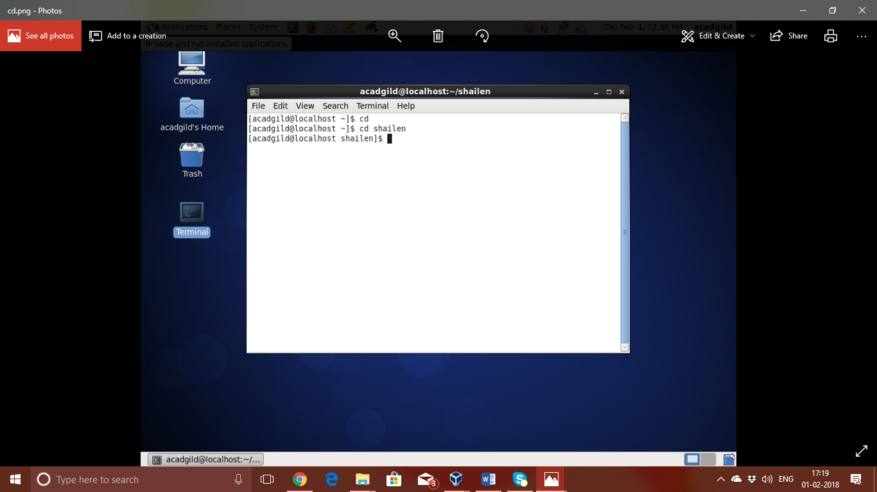

11.date

it is used to print out, or change the value of, the system's time and date information.

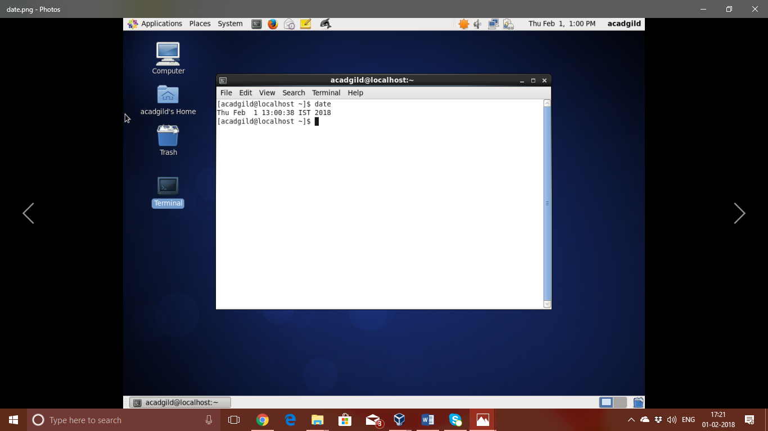

12.cal

It is used to displays a simple, formatted calendar in your [terminal](https://www.computerhope.com/jargon/t/terminal.htm).

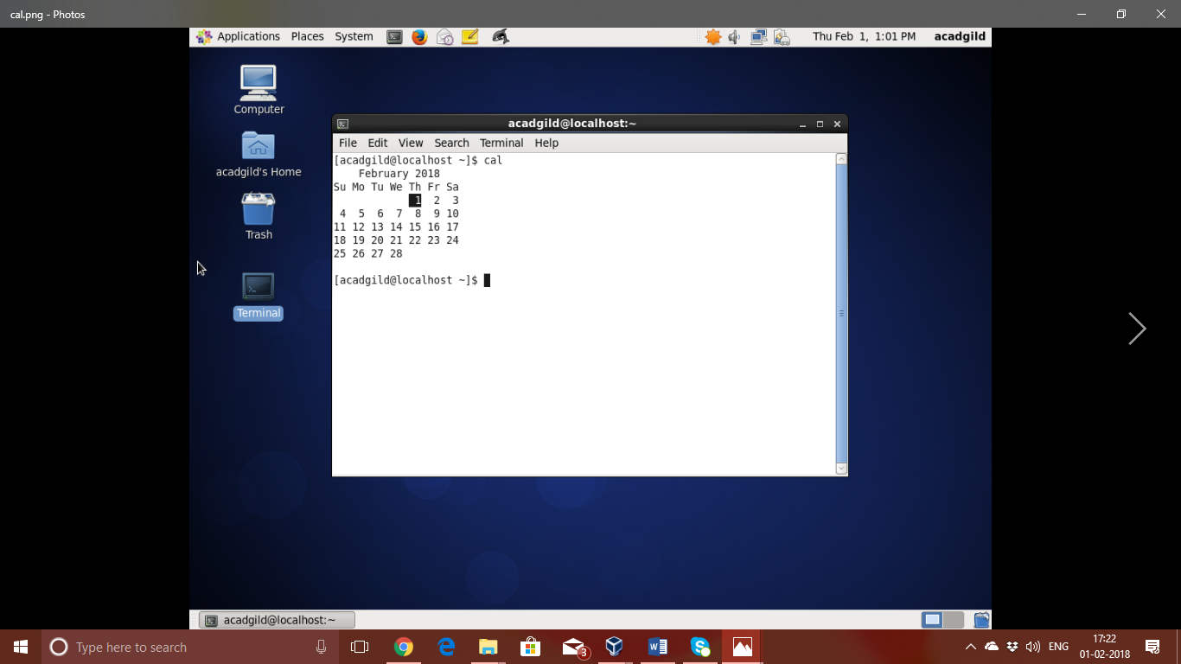

13.mv

it is used to move one or more files or directories from one place to another.

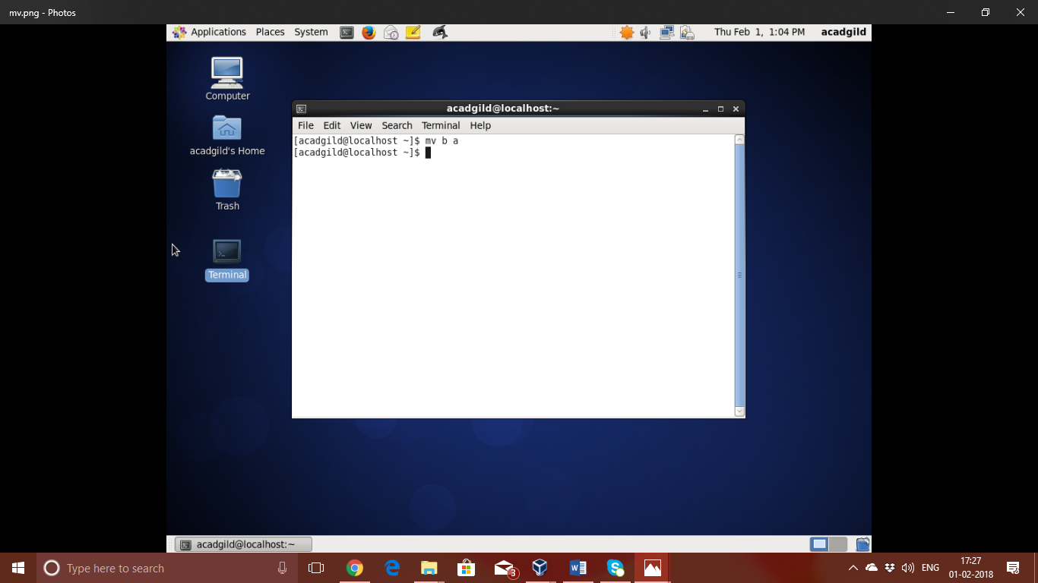

14.cp

It is used to copy files and directories.

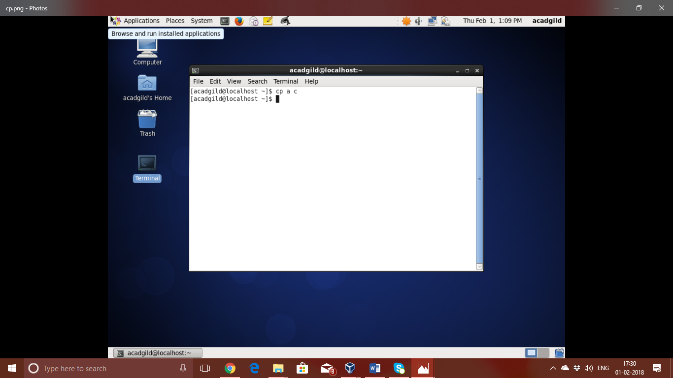

15.which

It is used to search the paths in the **PATH** [environment variable](https://www.computerhope.com/jargon/e/envivari.htm) for executable files matching the names of the arguments.

